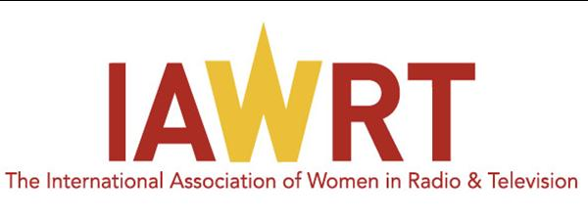
International Association of Women in Radio and Television

MEMBERSHIP APPLICATION FORM 2018 - 2020

The International Association of Women in Radio and Television (IAWRT) is a professional association which opens its membership to women who are actively engaged in the production and management of programs in the electronic media particularly in radio and television or in fields closely allied to broadcasting including internet publishing, video production, digital editing, animation, graphic design and lay-out, script writing and camera works.

- Personal Information

Last Name (Surname), First Name (Given Name) |  |  |  | Preferred Name
Complete Mailing Address

Work Phone (+Country and Area Codes) | Mobile Phone (+Country and Area Codes) |  | Home Phone (+Country and Area Codes)
Facsimile |  | E-mail Address
Date of Birth (DD-MM-YYYY)   - -  |  | Country of Residence

- Current Professional Engagement

Employer | Designation
Contact Information of Immediate Supervisor (Name, phone, e-mail) | Period of Employment
Office Address

Brief profile or description of professional electronic media activities or experience
____________________________________________________________________________________________________________
____________________________________________________________________________________________________________
____________________________________________________________________________________________________________
____________________________________________________________________________________________________________
____________________________________________________________________________________________________________
____________________________________________________________________________________________________________
____________________________________________________________________________________________________________
____________________________________________________________________________________________________________
____________________________________________________________________________________________________________
____________________________________________________________________________________________________________
____________________________________________________________________________________________________________

- Academic Background/ Electronic Media Training Attended

Highest Education/Training/ Qualification Attained in Media
____________________________________________________________________________________________________________
____________________________________________________________________________________________________________
____________________________________________________________________________________________________________

Others
____________________________________________________________________________________________________________
____________________________________________________________________________________________________________

ENDORSEMENTS

By Chapter Head, if applicable
____________________________________________________________________________________________________________
____________________________________________________________________________________________________________
____________________________________________________________________________________________________________
____________________________________________________________________________________________________________
____________________________________________________________________________________________________________

______________________________________
Signature over Printed Name of Endorsing Party

By Member
____________________________________________________________________________________________________________
____________________________________________________________________________________________________________
____________________________________________________________________________________________________________

Photo

______________________________________
Signature over Printed Name of Endorsing Party

Applicant’s Signature/ Date

Membership Fee:

Membership Entitlements

- Networking and exchange of professional experience with women in media from around the globe during international conferences, workshops, screenings, lectures, training sessions, etc.

- Opportunity to compete for the Biennial IAWRT Awards of Excellence in Radio and TV/Film Productions

- Access to dynamic newsletter and online publications

- Opportunity to apply for study scholarships and production grants

- Access members’ room or section in the website which contains contact details and information of IAWRT members around the world

Annual Membership | Fee in INR
Individuals | 1,500
Organizations/Groups | 5,000

Application Procedure and Process:

If you qualify for membership as defined above, please fill out this Application Form and submit to the IAWRT India Chapter.
Subscription cheques to be issued favouring International Association of Women in Radio and Television.

For Application Forms submitted online or by e-mail, expect an immediate automated acknowledgement of receipt. This application will then be forwarded to the Board who will review it and make the final decision. Applicants will be notified by
e-mail of the result of her application as soon as possible.
Applications may be sent to:
IAWRT Chapter India
Aparna Sanyal, Secretary
246, Top Floor, Narmada Apts,
Alaknanda, New Delhi 110 019, India.
Phone (+91) 98104 50052
E-mail: iawrtindia@gmail.com
Blog: www.iawrtindia.blogspot.com
Website: www.iawrtindia.org

